

**2021 HISTORIC PRESERVATION STUDENT COMPETITION**

**application Form**

**Name:** First and Last Name

**Guardian’s Name:** First and Last Name

**Grade Level:** Select Your Grade Level

**School:** Click here to enter text.

**Project Statement:** Tell us how your project addresses the topic of Meridian’s Legacy. Use about 50 – 250 words. (Lower grade levels are expected to use fewer words and higher grade levels are expected to use more words.)

**Project Medium:** Describe the medium that you are submitting your project in and   
why you chose this medium. What tools did you use to create your project?

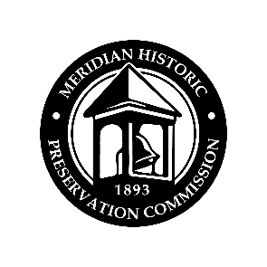

**2021 HISTORIC PRESERVATION STUDENT COMPETITION**

**Acknowledgments Form**

*If applicant is under 18, please fill out contact information for guardian that should be contacted.*

**Applicant:** First and Last Name

**Guardian:** *(if applicable)* First and Last Name

**E-mail:** Click here to enter text.

**Mailing Address:** Street number and name, City, State, Zip Code

**Phone:** Click here to enter the best number to reach you. **Is this a cell phone?** Yes No

**Parental Release**By allowing your/your child’s participation in the project, you consent to the City’s use of images of you/your child and your/his/her work, as well as your/your child’s name, grade, and school, for purposes of marketing or public information.

**Application Materials Checklist** Completed Application   
 Completed, signed Acknowledgements Form  
 Completed Project

**Declaratory Statement**I certify that to the best of my knowledge, the information contained in this statement is correct and complete. I understand that I will be disqualified from consideration of the 2021 Historic Preservation Student Competition if I do not submit the required materials.

**Signature:** **Date:** Click here to enter a date.

**Print name:** First and Last Name

*\*If Applicant is Under 18*

**Guardian Signature:** **Date:** Click here to enter a date.

**Guardian Print Name:** First and Last Name

To submit a project for consideration, please submit this Application and Acknowledgements form, completed and signed, and your project prior to the deadline either by in-person delivery to 33 E. Broadway Avenue, Suite 104, Meridian ID 83642 or by email at [hpc@meridiancity.org](mailto:hpc@meridiancity.org).

Thank you for your interest!